Tractor VCU PCB Revision
Changes Made | Previous PCB | Current PCB
Move 12V route to outer layer¹ | 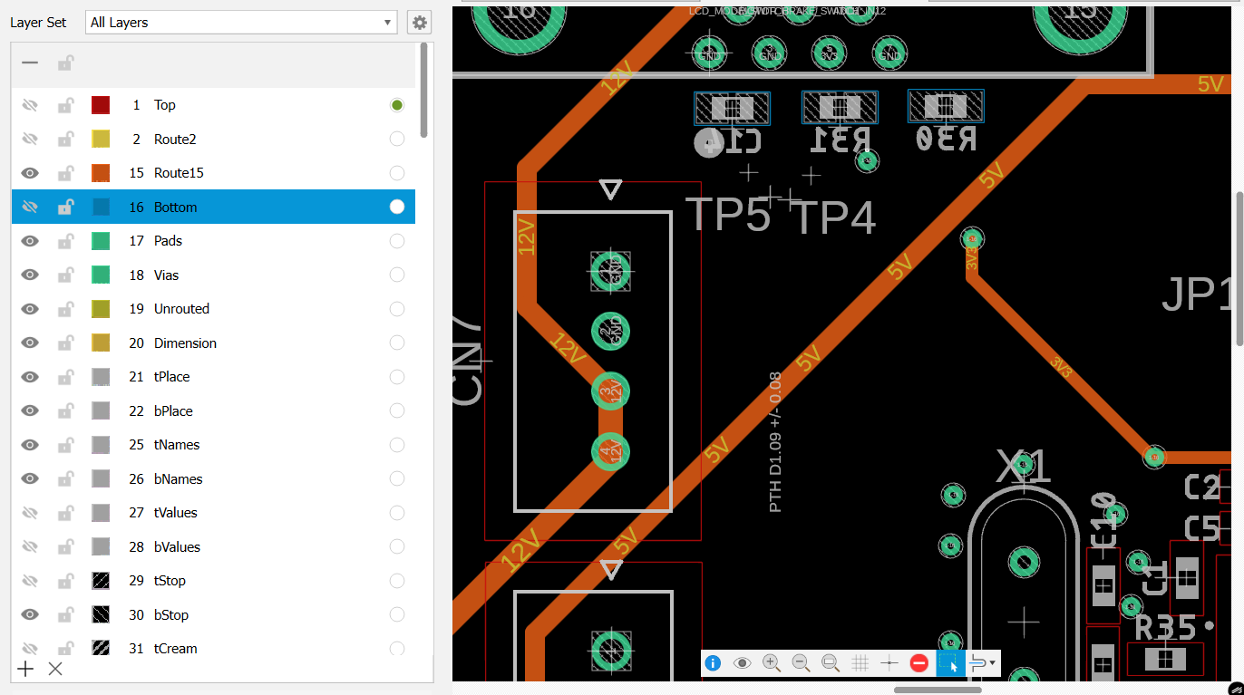  (Circled in light blue) | 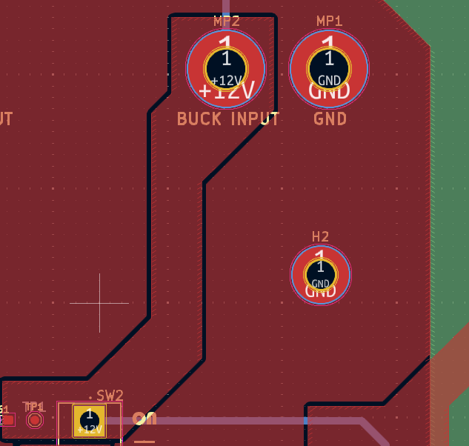  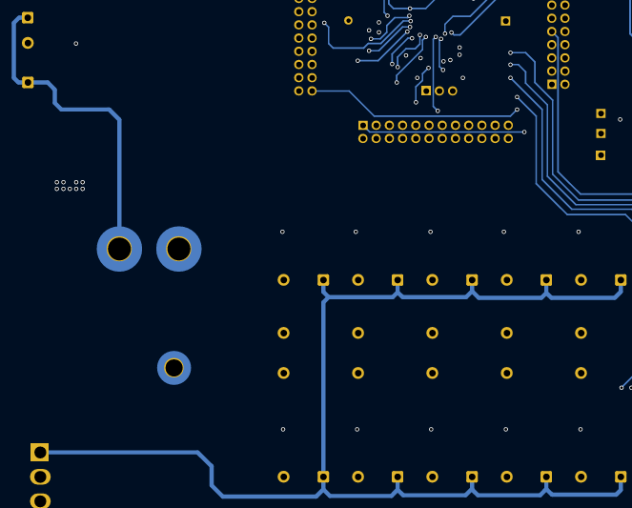
Separate ground plane for high and low-current¹ | 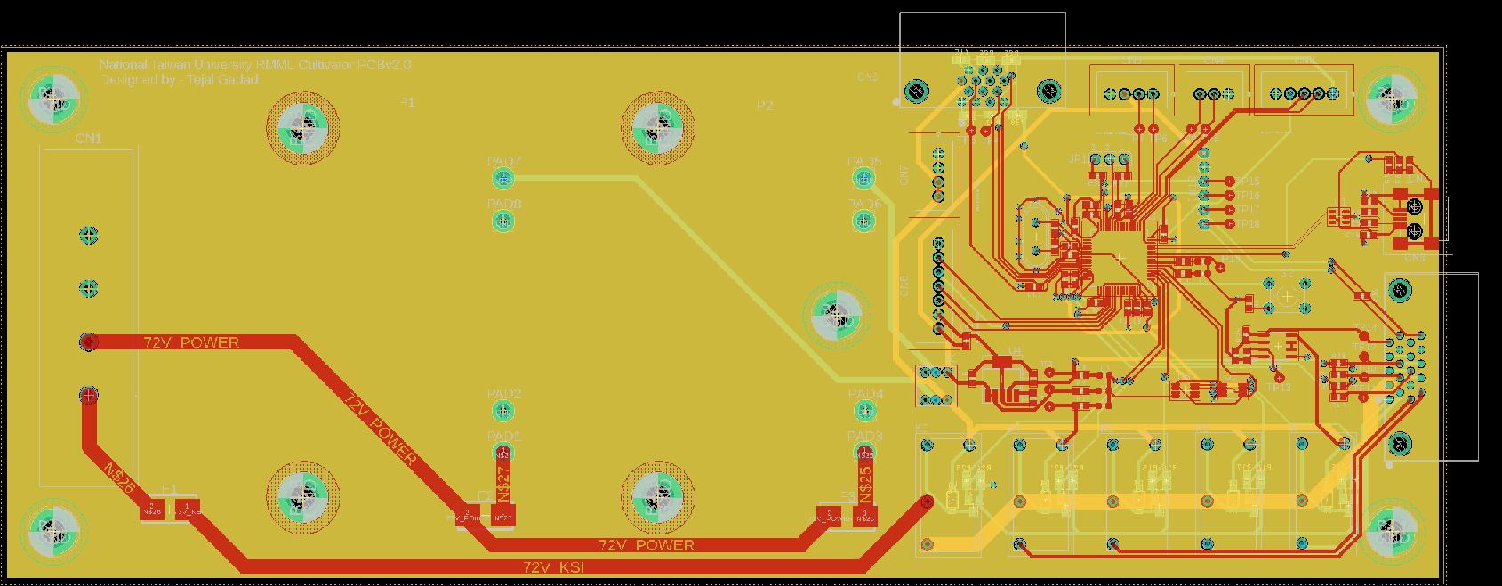 | High current:  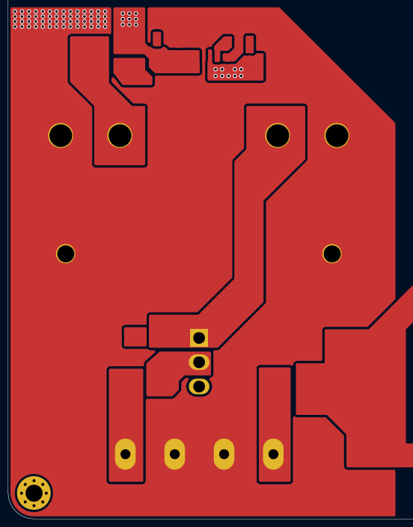  Low current:  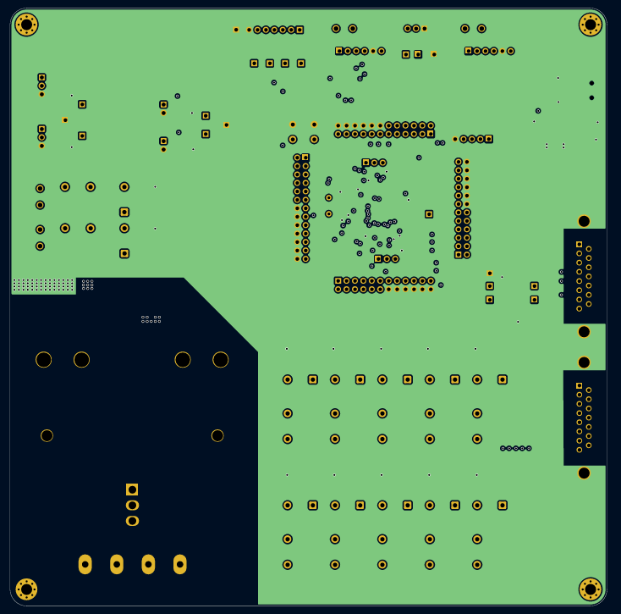
Component placement (STM32 decoupling capacitors) ¹² | 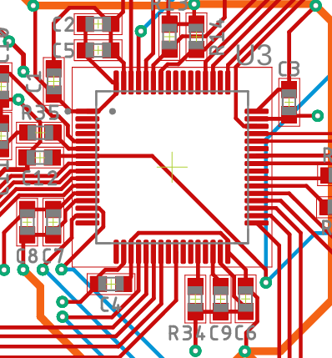 | 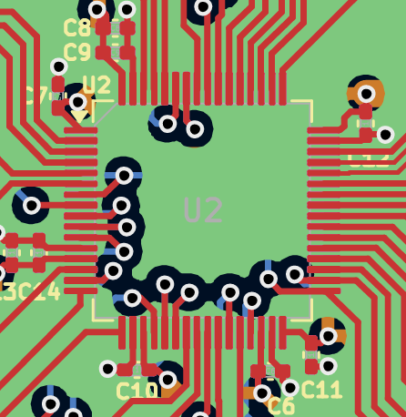
Capacitor footprint size for STM32 circuit | 0603 | 0402
Resistor footprint size for STM32 circuit | 0603 | 0402
Add extension pins | N/A | 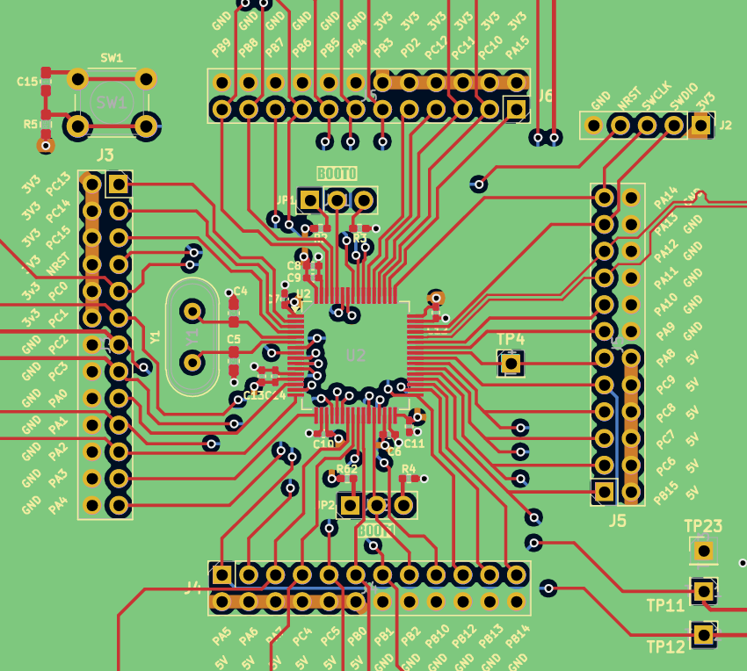
Fix reset circuit | 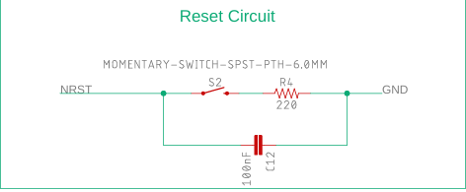 | 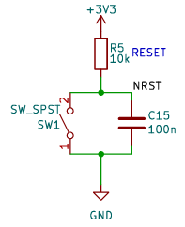
USB Circuit | 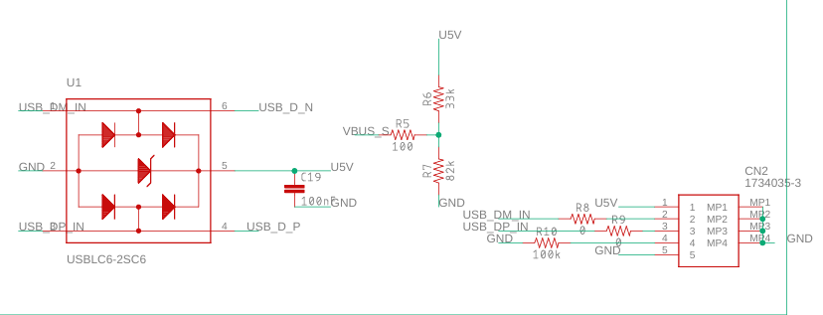 | 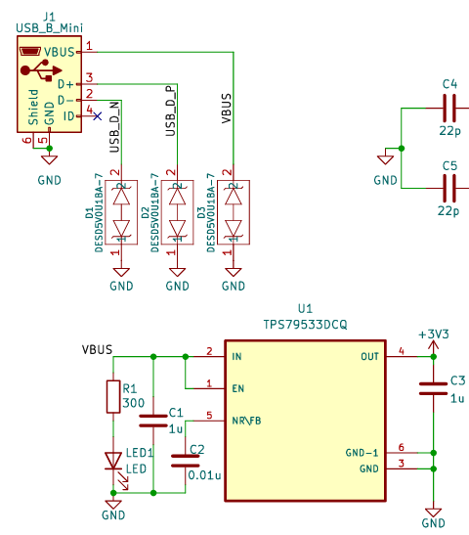
Add protection circuit (reverse voltage) | N/A | 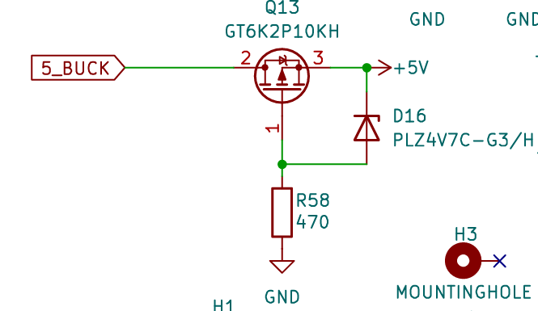
Add a ground point for test points³ | N/A | 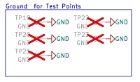
Change buck converters input and output connector | 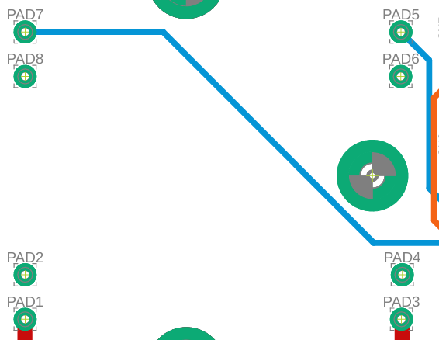  Connecting method:  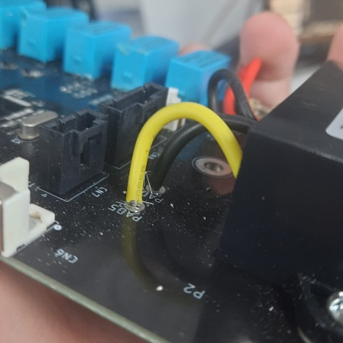 | 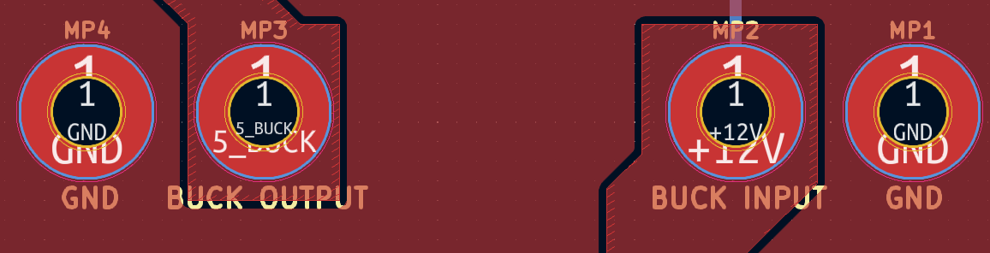  Connecting method:  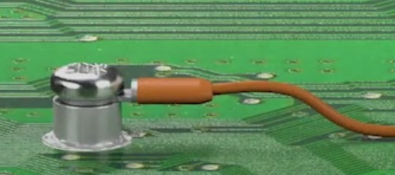

Notes:
¹Layer stacking:
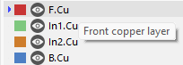
Red: Top -> Signal + Power
Green: Inner layer 1 -> Ground
Orange: Inner layer 2 -> Power
Blue: Bottom -> Signal + Power
²Schematic for STM32 decoupling capacitors
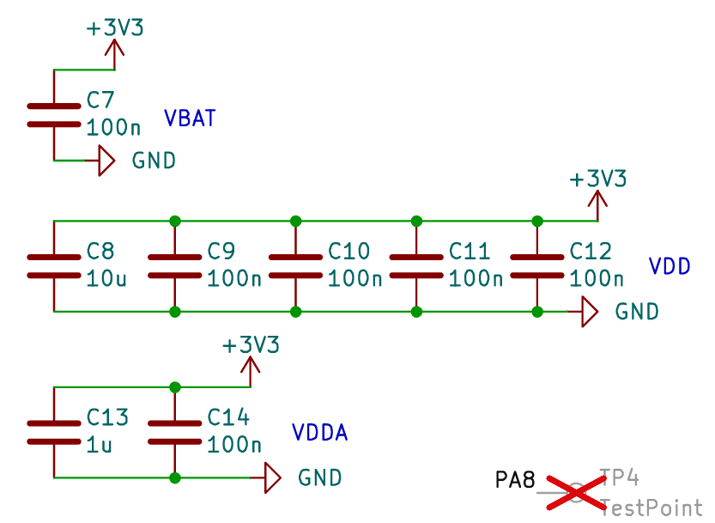
³Red cross is feature from KiCad to mark a component which is assigned as DNP (Do Not Place)

